AE 4451, Final Project

**Cycle Analysis of a Turbine Based Combined Cycle Mach 4 Engine**

By: **Noe Lepez Da Silva Duarte**

Spring semester, 2021

**Introduction and objectives**

Since mankind's first powered flight, a 12 second glide on a day in December 19031, engineers and scientists have striven to understand and control the mechanisms behind flight. Great progress has been made since, with commercial airplanes getting larger and more efficient while fighter jets are becoming faster and stealthier. However, while subsonic flight is well understood, supersonic flight, flights at speeds exceeding the speed of sound, are still challenging to reach efficiently. Indeed, supersonic conditions bring many challenges which impact all aspects of airplane design and propulsion. As such, the aim of this paper is to design and analyse the performance of an air-breathing engine capable of reaching Mach 4 at different points on its flight path.

This will be achieved by using a Turbine Based Combined Cycle engine (TBCC), to power a missile. The TBCC engine builds multiple modes around a turbojet (TJ) core2, with a ramjet (RJ) bypass on the sides. The ramjet fuel injectors and combustion chamber are behind the TJ turbine exit, to enable the use of the ramjet combustion chamber as an afterburner (AB) to reach desired velocities. An inlet spike is also used to redirect the flow through the ramjet as Mach 2.5 is reached. The preliminary engine design is shown in figure 1. While figure 1 is highly inaccurate as it is an artist rendition of what the engine is expected to look like, inspired by SR-71 engine design and generic hybrid (mixed cycle) ramjets3, it is useful in apprehending how the TBCC will function. The engine will start with only the turbojet on for launch. The missile will be launched at the optimal angle of 20° to obtain maximum range throughout the 5 minute climb to 7620m (25000ft). Once the TBCC has reached design altitude, fuel injectors will turn ON and start afterburning to reach mach 2.5, where the RJ will take over for the remainder of the flight. As such, the engine performance and efficiencies will be determined at takeoff (TJ only), subsonic cruise (TJ), supersonic cruise (TJ+AB), ramjet initial phase (TJ+RJ), ramjet acceleration, and ramjet cruise.

Certain engine characteristics were set to allow for performance analysis. The inlet mass flow rate ([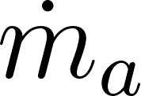](https://www.codecogs.com/eqnedit.php?latex=%5Cdot%7Bm%7D_a#0)) is 80kg/s, the TJ compressor pressure ratio (PR) is 10, the fuel used is Decane, C10H22, with heating value (QR) of 44.24MJ/kg[4] and the inlet diameter it 0.8m, for an area of 2m2. In addition, numerous assumptions are made throughout the design and analysis process of the TBCC. Firstly, the flow is assumed to be a calorically perfect gas, with no losses (isentropic) throughout. Cp (specific heat capacity at constant pre ssure), R (air’s specific gas constant), and 𝛾 (specific heat ratio) are deemed to be constants equal to 1.004 kJ/kgK, 287 J/kgK and 1.4 respectively. Accelerations are deemed to be constant, and mach number inside combustors is assumed to be negligible. Moreover, the exit pressure (Pe), is assumed to be equal to the surrounding pressure (Pa) at all times. Finally, ideal cycles are also assumed. The impact of these assumptions will be discussed later in this paper.

**Results and Discussion**

All analysis was done using a Python script, allowing for the recursive analysis of characteristic performances to fine tune them until the desired velocities are reached, by varying the stagnation temperature in the combustors. Numerous isentropic relations are present in the code to allow for easy determination of pressures, temperatures and mach numbers.

Takeoff and Subsonic Cycle Analysis

As both takeoff and subsonic cruise only make use of a TJ, the same process is used to calculate their characteristics. Firstly, stagnation pressures (P0) and temperatures (T0) before and after the compressor are calculated using isentropic relationships and PR. It must be noted that M, mach number, at takeoff is assumed to be 0, as the craft is not moving yet. While stagnation pressure at the combustor exit (station 4) is assumed to be equal to the stagnation pressure at the compressor exit (station 3), the fuel flow rate ([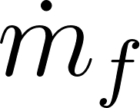](https://www.codecogs.com/eqnedit.php?latex=%5Cdot%7Bm%7D_f#0)) is calculated using equation (A.1) using a predetermined value for T04. These are 645K at takeoff and 600K during subsonic cruise. Next pressures and temperatures at the turbine exit (station 5) must be determined. As the engine is in a missile, all the power from the turbine is assumed to be equal to the power required to run the compressor, as no additional power is needed to run the craft. In addition, as [](https://www.codecogs.com/eqnedit.php?latex=%5Cdot%7Bm%7D_f#0) << [](https://www.codecogs.com/eqnedit.php?latex=%5Cdot%7Bm%7D_a#0), *f*, the fuel-to-mass flow rate is negligible, allowing for the assumption that Cp is constant throughout the engine. Therefore, equation (A.2) is used to determine T05. Finally, exit velocity can be calculated.

The change in entropy, thrust, TSFC and efficiencies are then determined using temperatures and pressures throughout the engine. Change in entropy is approximated from equation (A.3), to plot temperature-entropy (T-s) diagrams of the cycle in Figures 2 and 3. Next thrust and TSFC are calculated from mass flow rates and exit velocities. Finally, due to the ideal cycle assumption, the TJ cycle can be approximated as an ideal Brayton cycle to find efficiencies from equations (A.4) and (A.5).

Afterburner Cycle Analysis

While the initial TJ cycle processing stays the same as during takeoff and subsonic cruise, with T04 equal to 680K, the afterburner adds slight complexity to the cycle analysis, as it heats the flow up to 1750K at T06, to accelerate the flow to supersonic velocities. Stagnation pressure is assumed to stay constant from the turbine exit up to the nozzle exit and stagnation temperature is also assumed to be constant past station 6. The fuel flow rate is then calculated from (A.1), using temperatures at stations 6 and 5. The afterburner cycle is plotted in figure 4.

Turbojet to Ramjet, Ramjet Acceleration and Cruise Analysis

Due to the high velocity, compressing the flow increases its temperature to over 1000K, which is unsafe for the TJ components. As such, no fuel is added in the turbojet to avoid melting the turbine, and the stagnation is assumed to be constant from the compressor to the combustor exit. As a result, the TJ cycle is a line as seen in figure 5.

On the other hand, a single normal shock in the engine ramjet bypass is assumed to compress the flow. As such, normal shock wave equations and tables5 were used to determine flow characteristics after the shock. As ramjets also use Brayton cycles, temperatures and pressures in the ramjet were calculated using the same relationships and assumptions as for the turbojet with T04 equal to 1700K during the switch to fully ramjet and 1600K throughout ramjet acceleration and cruise. The cycles for TJ to RJ, RJ acceleration and RJ cruise are shown in figures 5 to 7.

While the change in entropy is calculated for each cycle, the compression in the ramjet is assumed as isentropic in figures 5, 6 and 7, to obtain ideal cycles. However, this is incorrect, as flow across a normal shock cannot be isentropic. As such these cycles are re-plotted in figures 8, 9, 10. It can be seen that a significant amount of entropy is created across the shock, implying significant losses. This is to be expected, as the ramjet must slow down the flow for the fuel to be able to combust in the combustor.

Fuel use and Range Analysis

Table I compiles numerous engine characteristics at the chosen points during the flight path. The thrust significantly decreases as the TBCC reaches cruise conditions, both during subsonic and supersonic cruise, making TSFC increase. This is largely due to two assumptions, Pe = Pa and that the missile is able to reach a velocity equal to its exit velocity. Indeed, the prior assumption is not always valid, especially at higher altitudes, yet, greatly simplifies the cycle analysis, by allowing P5 to be known, while also reducing the thrust by neglecting pressure thrust. In addition, while the latter assumption is valid as aerodynamic effects are neglected, it further reduces thrust during cruise.

On the other hand, fuel use follows expected trends, with higher fuel usage during accelerations than during cruise. Using this data, along with the time in each stage, 5 minute takeoff and climb, 1 minute subsonic cruise, 1 minute acceleration using afterburner, 1 minute change from TJ too RJ, 1 minute acceleration to max velocity and 11 minute supersonic cruise, while assuming that fuel consumption stay constant throughout each phase (which is somewhat inaccurate as fuel flow rate will decrease as a function of velocity since the air in the compressor will become hotter as velocity increases, making [](https://www.codecogs.com/eqnedit.php?latex=%5Cdot%7Bm%7D_f#0) decrease slightly), it is possible to find the TBCC’s fuel consumption. Therefore the TBCC will use 939.68kg of fuel in 20 minutes.

Similarly, range was calculated using the constant acceleration assumption and ignoring aerodynamic effects such as parasite and transonic drag. This is assumed as, while thrust will decrease as velocity increases, mass will also decrease, allowing for acceleration to stay constant. As such, range can be determined by calculating the average velocity of the craft during a specific flight portion, and multiplying it by the time. Therefore, for a 20 minute flight requiring almost 1 ton of fuel, the craft will have a range of 1141km.

Fuel and Range Approximations

Implemented in the code are ways to determine the fuel consumption for a given range, and the range for a given amount of fuel. These are approximations as they compare the given fuel amount or range with the default design ranges and fuel needed. This is possible due to prior assumptions that fuel consumption and acceleration stays constant throughout each stage. Therefore it is possible to determine that the engine will need approximately 1427.02 kg of fuel to have a range of 2000km, or that it will travel almost 3000km with 2000kg of fuel.

Impact of Cruise Altitude

Using the script, cruise altitude can also be changed to determine the impact of cruise altitude on range and fuel consumption, by inputting the pressure and temperature at that altitude. Changing cruise altitude from 25000ft to 40000ft only causes a marginal increase in both range and fuel use, while assuming the TBCC engine will take the same amount of time to climb to cruise altitude. As such, if the climb time is increased, the ramjet will be ON for less time, greatly reducing the range. Therefore, 25000ft is used as an optimal cruise altitude.

Efficiency analysis

As the Turbojet’s pressure ratio does not change, its thermal efficiency stays constant, as the temperature difference between the compressor entrance and exit will stay the same, yielding an efficiency of 0.48. While this could be increased using a higher pressure ratio6, more fuel would be needed to provide enough power for the compressor. The Ramjet’s thermal efficiency increases with velocity for a maximum of 0.79 while keeping a high propulsive efficiency. As such, the TBCC engine is most efficient during supersonic cruise, with only the ramjet ON.

**Conclusions**

This paper describes a turbine-based combined cycle engine concept in which a turbojet and ramjet were integrated to provide thrust to mach 4, which was designed and analysed using a highly customizable Python script (see Appendix B. or read_me.txt for more information on how to use the program). Indeed, results of a rudimentary cycle analysis imply that the integration of a turbojet with a generic ramjet is feasible. The TBCC designed in this paper would cruise at 25000ft and could cover a range of 1141km while carrying 939.68kg of fuel in 20 minutes.

However, numerous assumptions were taken in the analysis process of the engine. Some have a small impact on calculations, such as assuming that mach number is combustor is 0 or Cp, R, and 𝛾 are constants, to simplify the analysis process, others significantly impact thrust and TSFC for example, by assuming that pressure thrust is negligible and that the craft is able to reach the same velocity as exit velocity.

All in all, this paper was successful in designing and analysing a TBCC propulsion system. Further analysis of this engine concept could be undertaken in the future, by determining engine characteristics throughout a flight rather than at given points in the flight path. The engine analysis could also be more accurate by removing the assumptions taken throughout the paper. Finally, aerodynamic analysis could also be done (or values could be assumed to obtain) more accurate ranges.

**Figures and Tables**

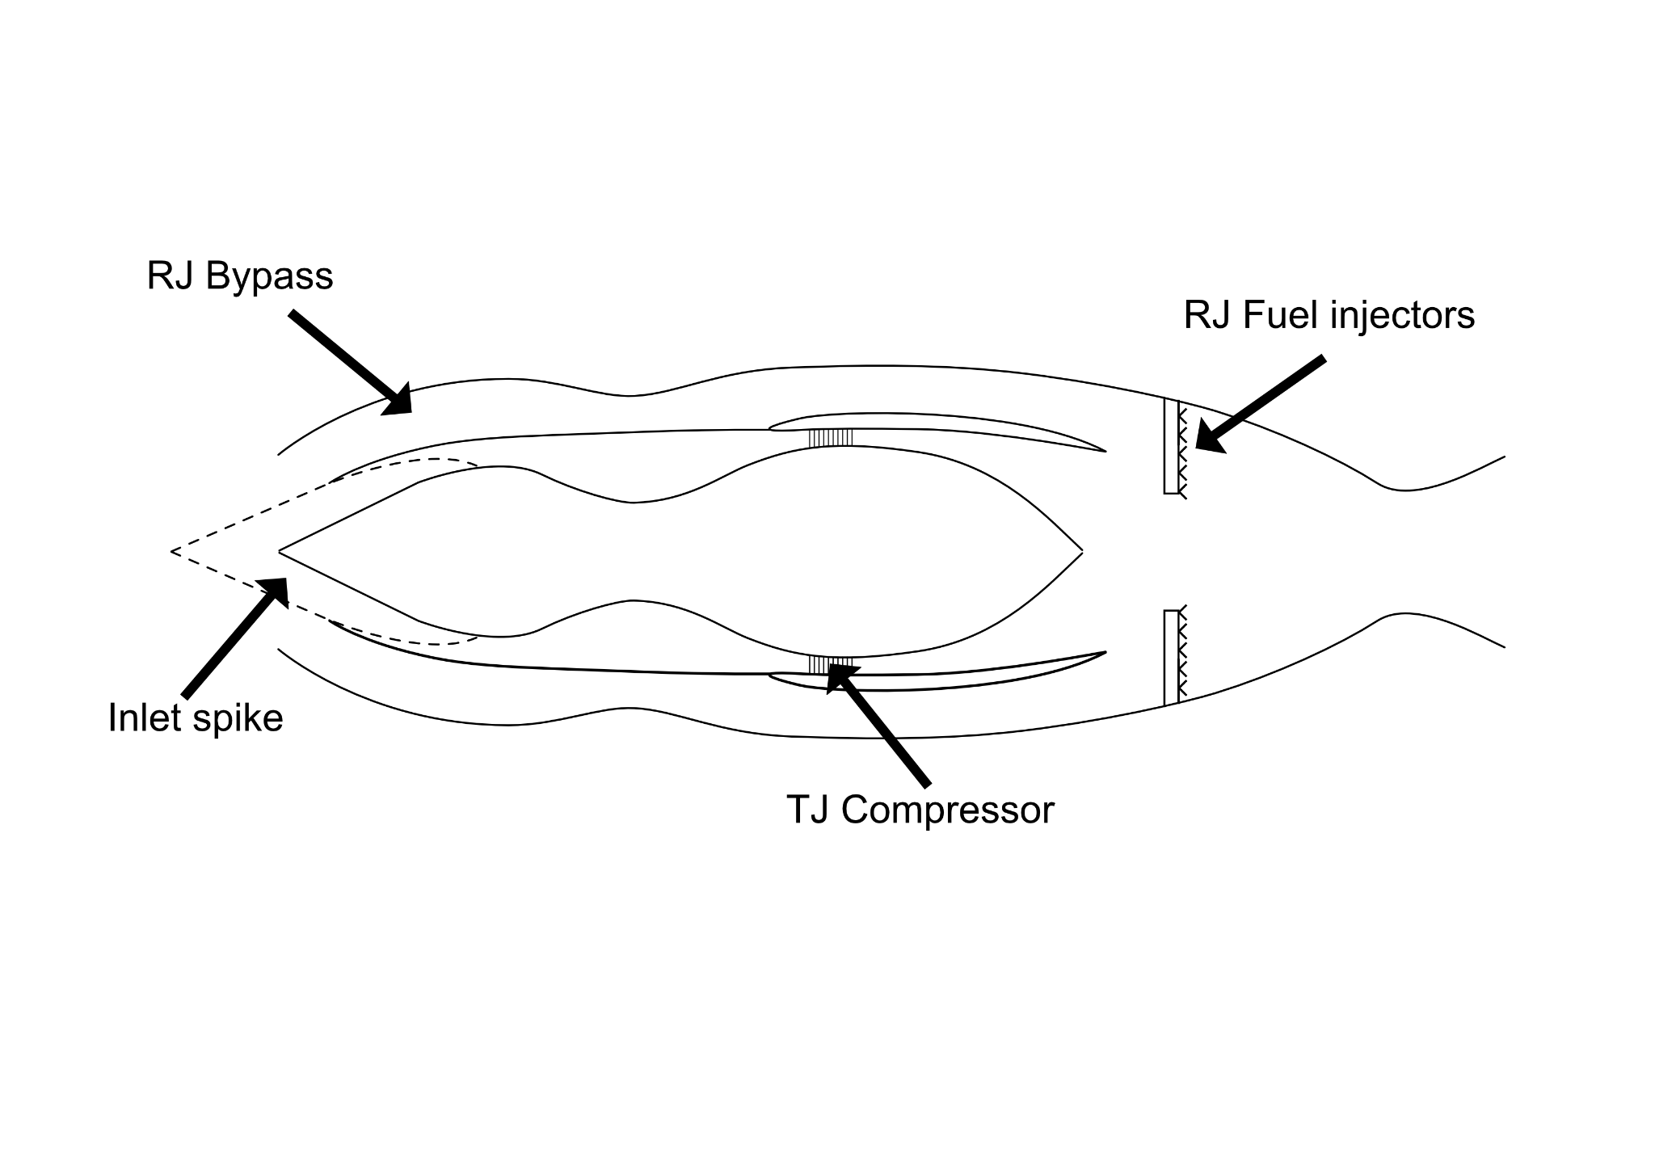

Figure 1. Artist rendition of TBCC engine design

|  |  |
| --- | --- |
| Figure 2. T-s Diagram of the TBCC at takeoff | Figure 3. T-s Diagram of the TBCC during subsonic cruise |

|  |  |
| --- | --- |
| Figure 4. T-s Diagram of the TBCC during afterburner acceleration | Figure 5. T-s Diagram of the TBCC during ramjet startup |

|  |  |
| --- | --- |
| Figure 6. T-s Diagram of the TBCC during ramjet acceleration | Figure 7. T-s Diagram of the TBCC during ramjet cruise |

|  |  |
| --- | --- |
| Figure 8. T-s Diagram of the TBCC during ramjet startup with change in entropy across the normal chock | Figure 9. T-s Diagram of the TBCC during ramjet acceleration with change in entropy across the normal chock |

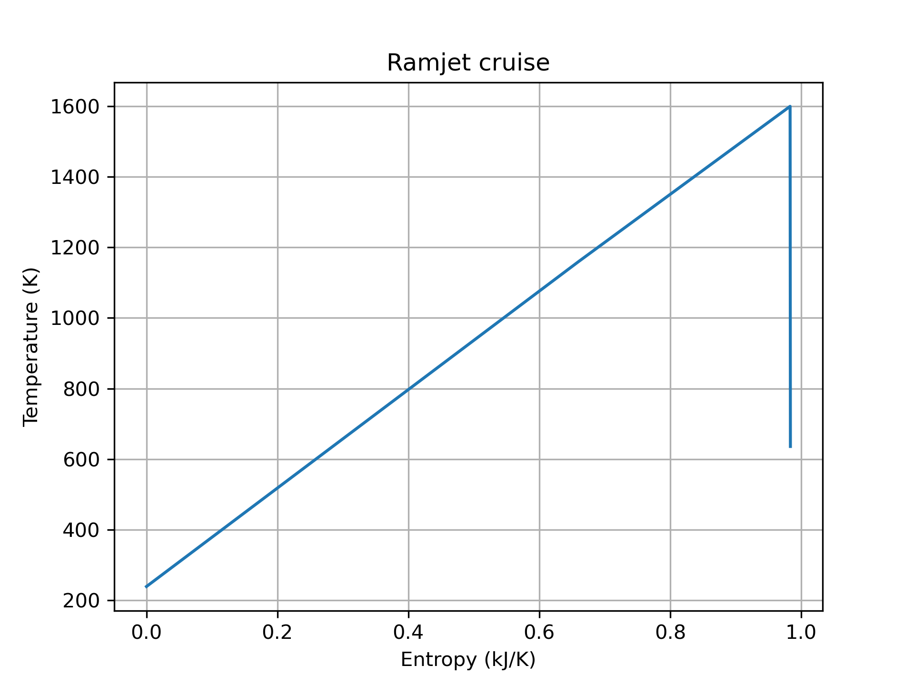

Figure 10. T-s Diagram of the TBCC during ramjet cruise with change in entropy across the normal chock

Table I. Exit Mach number, thrust, TSFC, fuel flow rate and turbine power in the TBCC at chosen points in the flight path

|  |  |  |  |  |  |
| --- | --- | --- | --- | --- | --- |
|  | **Exit Mach number** | **Thurst (kN)** | **TSFC (g/kNs)** | **Total Fuel flow rate (kg/s)** | **Turbine power (kW)** |
| **Takeoff** | 0.87 | 23.6 | 6.81 | 0.16 | 21.5 |
| **Subsonic Cruise** | 0.89 | 0.6 | 222.49 | 0.13 | 20.5 |
| **Afterburner ON** | 2.56 | 41.6 | 6.39 | 2.68 | 20.7 |
| **TJ to RJ** | 3.90 | 35.7 | 58.46 | 2.09 | 41.1 |
| **RJ acceleration** | 4.39 | 13.8 | 83.66 | 1.16 | - |
| **RJ cruise** | 4.49 | 3.7 | 217.7 | 0.8 | - |

Table II. Efficiencies of the TBCC at chosen points in the flight path

|  |  |  |  |  |
| --- | --- | --- | --- | --- |
|  | **TJ Thermal Efficiency** | **RJ Thermal Efficiency** | **Propulsive Efficiency** | **Total Efficiency** |
| **Takeoff** | 0.48 | - | 0.00 | 0 |
| **Subsonic Cruise** | 0.48 | - | 0.99 | 0.48 |
| **Afterburner ON** | 0.48 | - | 0.52 | 0.25 |
| **TJ to RJ** | 0.48 | 0.54 | 0.82 | 0.21 |
| **RJ acceleration** | - | 0.74 | 0.94 | 0.70 |
| **RJ cruise** | - | 0.79 | 0.99 | 0.78 |

**References**

1“1903-The First Flight,” Wright Brothers National Memorial, Available at: https://www.nps.gov/wrbr/learn/historyculture/thefirstflight.htm, 2015.

2Clough, J., “Modeling and Optimization of Turbine-Based Combined-Cycle Engine Performance,” Graduate School of the University of Maryland, 2004.

3Fry, R., “A Century of Ramjet Propulsion Technology Evolution,” *JOURNAL OF PROPULSION AND POWER,* Vol. 20, No. 1, January–February 2004.

[4]McAllister, S., et Al., “Fundamentals of Combustion Processes,” *Mechanical Engineering Series*, Springer Science+Business Media, 2011.

5Hall, N., “Normal Shock Wave Equations,” National Aeronautics and Space Administration, Available: https://www.grc.nasa.gov/www/k-12/airplane/normal.html

6Hill, P., et Peterson, C., “Thermodynamics of Propulsion,” Pearson Education, 2012.

Access this document at:

https://docs.google.com/document/d/1ENTH35CvY9K8GJGBKdjjPf5Ss04YmFxeAx4a9gTNP3M/edit?usp=sharing

**Appendix**

**A. Equations**

|  |  |  |
| --- | --- | --- |
|  |  | (A.1) |

|  |  |  |
| --- | --- | --- |
|  |  | (A.2) |

|  |  |  |
| --- | --- | --- |
|  |  | (A.3) |

Where subscripts stand for the initial state (1), and final state (2)

|  |  |  |
| --- | --- | --- |
|  |  | (A.4) |

|  |  |  |
| --- | --- | --- |
|  |  | (A.5) |

**B. Using the Cycle analysis tool**

The analysis tool is available as both a Python script or .exe executable file. To run the program, one simply has to double click the .exe file on a Windows machine, or open the .py file with a Python Interpreter (open the file as administrator to ensure the file will be able to be printed). A window similar to figure B.1. will open.

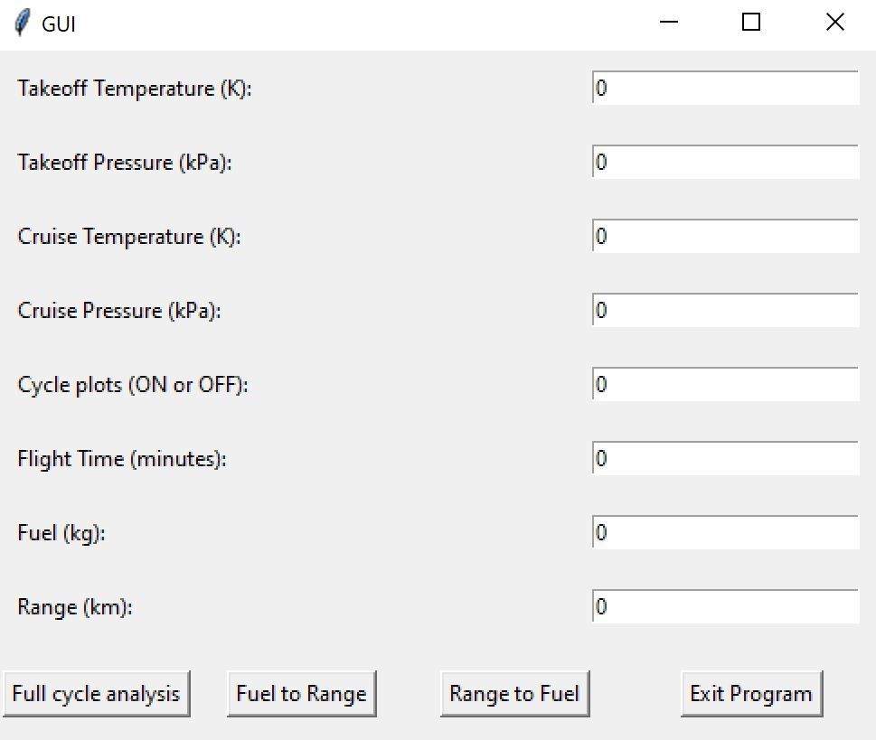

Figure B.1. Program GUI window

This allows the user to input variables they would like the program to run. However, design variables are already coded in, as to run the script using design variables when all GUI inputs are left as 0. The default inputs are as follows (from top to bottom): 288.15, 101.3, 238.68, 37.65, OFF, 20, 939.68, 1141.37. The last two variables, fuel and range depend on the first four inputs and will change if these are not 0 (they are not hardcoded).

If ON, the cycle plot input will print out and save the T-s cycle diagrams of each point in the flight path at the location where the file is run when the ‘Full cycle analysis’ button is pressed. Pressing this button will run the ‘fullFlight’ function, which runs the code to find the temperatures, pressures, entropy changes, thrust, TSFC, fuel flow rates and efficiencies of the engine at each point in the flight path. All this information is printed in a txt file named ‘Outputs_NoeDSDL.txt.’

The Fuel input is only used if the ‘Fuel to Range’ button is pressed. This determines the range of the TBCC for a given amount of fuel and prints it out in the same file as the other buttons. Similarly, the range input is only used if the ‘Range to Fuel’ button is pressed and prints out the fuel needed to achieve a given range. Please note that these estimations are most accurate for the design takeoff and cruise altitudes, as the climb time is set to 5 minutes, and the program will not account for different climb times based on new takeoff or cruise altitudes. Yet, this can be changed in the code itself, by changing the last input of the “TJCycle” functions at lines 463, 667, or 727.

Finally, exit the program before opening the .txt outputs file, as the script will only finish printing the information once the program is terminated.